The World Above 30 MHz 2 August 2026

In today’s tutorial we are going to talk again about Trans Equatorial Propagation or TEP and Sporadic E.

In April this year we introduced the term Trans Equatorial Propagation.
We then said that it is a type of F2 propagation that manifests equidistant across the magnetic dip equator.

Let us dig a little deeper into this VHF propagation type. Looking at the Amateur Radio Wiki on Trans Equatorial Propagation we see that there are two distinct types of TEP

- Openings occurring during the late afternoons and early evenings on the low VHF bands such as 6m and covering a distance of up to 6000 km.
- Openings occurring later in the evenings around 19:00 – 23:00 local time on 2m and even 70cm.

There is an effect known as the “equatorial anomaly” which occurs where a high level of electron concentration is found on each side of the magnetic equator.

Afternoon TEP is believed to occur when a signal is reflected first by an anomaly on one side of the equator and then again by another anomaly on the other side.
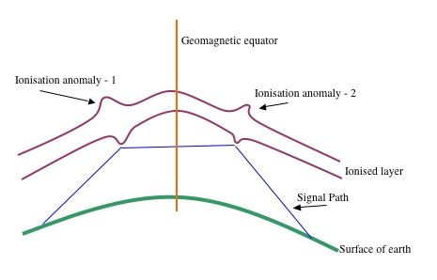

Evening TEP is less well understood, but is believed to rely on "ionospheric bubbles" - areas of high ionisation density off which signals are reflected.

Both these TEP types occur at time of high sunspot activity.
Let us look at the website of NASA Jet Propulsion Laboratory - California Institute of Technology and look at the Global Ionospheric (TEC) Maps. We will see that the total electron content at 17:40 UTC which is 19:40 local time, and we will see a picture, that supports the description provided above. There are two distinct areas where the TEC is higher on both sides of the geomagnetic equator.
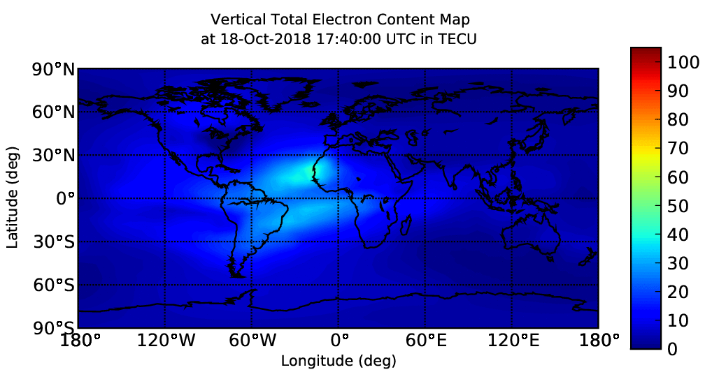

This map is updated every 5 minutes and if we keep an eye on this map we should see the TEC levels increasing. Looking for historical information on the TEC took me to the NOAA Space Weather page for where there was an animation that shows the recorded TEC for the current day. Playing the animation showed me in the lower right corner over the mid Atlantic that the TEC reached a level above 80.

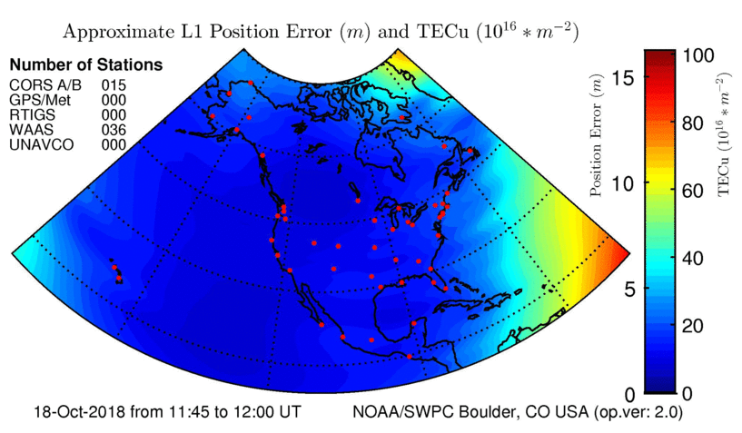

Could the TEC be used to predict when TEP may be possible?

What about Sporadic E?
Sporadic E propagation bounces signals off smaller clouds of unusually ionized atmospheric gas in the E layer. In the Southern Hemisphere activity starts around mid December and peaks in late December.
Equatorial E-Skip occurs over the equatorial regions and is common in the temperate latitudes in late spring and in early summer. The temperate latitudes are the areas on the Earth between the subtropics and the polar circles, which means Southern Africa and most of Europe.

Take a look at the IONMON Maps website of the European Space Agency that also shows the TEC for the previous day.

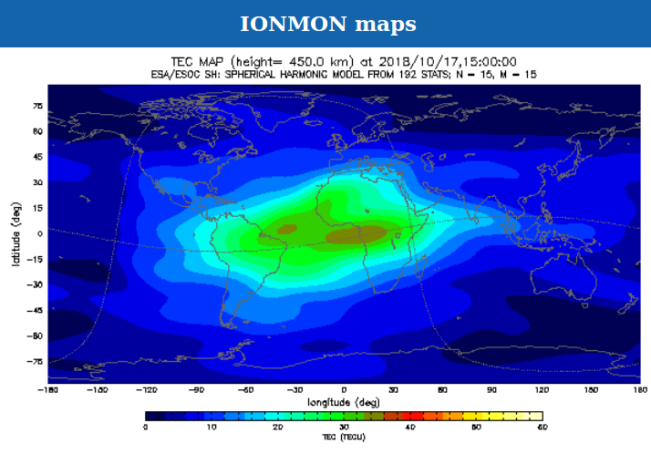

You will see the high TEC over the equatorial region of Africa.

When comparing the NASA JPL TEC maps and the ESA TEC maps you will see that there is quite a significant difference. The NASA TEC maps are produced by monitoring the GPS system which is developed by the US and the ESA TEC maps are produced by monitoring both the GPS and GLONASS systems. The GLONASS system is developed by Russia.

Either way the maps show the increased electron content of the ionosphere.

Maybe we need to start monitoring those 10m and 6m beacons in Europe and see if we hear anything.

The text version of this tutorial on the SARL web includes links, diagrams and screen shots of the TEC maps.
The text version of the program on the https://www.amsatsa.org.za/ website includes links, diagrams and screen shots of the TEC maps.

How about telling us about that exciting long distance contact that you have made on the VHF and above bands or about that project that you are working on in the VHF and above bands? Send me a consolidated report of your activity or project with any additional photos, audio or video clips to bjacobsza@gmail.com.

Remember by sharing your activities with us, allows us to tell the rest of the amateur community about your achievements and the more we promote the activity on the VHF and above bands the better chance we have of encouraging more amateurs to explore the world above 30 MHz.

This program is compiled, edited and presented for Amateur Radio Today by Brian Jacobs ZS6YZ.

